Fall 2014 Senior Design Proposal

Group 2

Prepared for:

Dr. Latcha

Dr. Gu

By:

Paul Kruchko (EE), Project Manager

Michael Laba (ME), Mechanical Design Team Lead

Bryan Jagielo (EE/CE), Electrical and Controls Team Lead

Xiaoang Tong (EE)

Monika Shaeff (CE)

Ran Ao (ME)

Xinfeng Shi (ME)

September 23, 2014

**Introduction**

Senior Design Group 2 was assigned the task of constructing a machine that could efficiently and accurately count parts needed by an assembly worker and dispense those parts into a worker’s awaiting hand, thereby reducing the chance of parts being dropped on the floor and discarded. This proposed device has the potential for optimizing throughput time in the assembly process while saving money in lost and discarded parts.

**Proposed System**

The system that Group 2 proposes is a closed-loop, feed-back, electronically controlled vibratory bowl feeder that agitates, actuates, and organizes a set of homogenous hardware components that are to be counted and dispensed into the awaiting hands of the operator/user.

The overall structure of the system is a bowl that serves as a hopper and transducer placed at the rear-end of the system. Inside the bowl is a spline that ascends to the top of the bowl and narrows along its path. Meeting the spline at the top of the bowl is a PVC tube and a control gate that is attached to an RC servo motor. Attached to the tube are 6 pairs of diametrically opposing photo electronic sensors, evenly spaced to count parts to be dispensed and measure the velocity of those parts. Waiting at the end of the tube is a staging trough that can dump the counted parts into the dispense funnel or into the reject bin. At the front end of the system is a flat panel that contains the user interface (UI) and dispense door. The UI consists of; a red lamp and a green lamp, a 2x16 LCD display, a six position granulated turn knob, a “Start” button, a “Load” button, a “Select” button, a “Up” button, a “Down button” and a NEMA certified emergency stop button. At the bottom of the front panel is a door that the user must push in with his/her hand to receive the requested number of parts.

The overall theory of operation of the system is that the user would deposit no more than 50 parts at a time in the vibratory bowl, which doubles as a hopper. Once the user has deposited the parts to be counted and dispensed into the bowl, the user would initiate the load sequence of the machine by pressing the “Load” button. Then the machine would output on the LCD screen, “Please select a part.” The user would then select the profile of the part using the “Up” and “Down” keys and once the desired part was displayed on the LCD screen the user would then press the “Select” button. The loading sequence would cause the vibratory action of the bowl to begin and agitate the parts in the bottom of the bowl to start to move along the dispense path. During the loading sequence the red lamp is illuminated and the LCD displays, “Loading…”

This vibratory action is produced by periodically energizing a pair of opposing electromagnets in the base of the bowl. The bowl itself would be mounted to a cross member that would have two armatures attached to it that would be pulled towards the electromagnets when energized. The motion due to magnetic forces would then be complimented by a pair of leaf springs that would snap the bowl back into its original position on the de-energized state of the electromagnets. This periodic motion would produce a coupled moment on the bowl that would then be transferred to the parts inside.

The moment produced would cause a mass flow rate of the parts to begin, with the moment turning into a normal and tangential angular acceleration on the individual parts. The tangential acceleration on the masses would produce a force that would cause the individual parts, collectively, to move along a spiral path ascending up the sides of the bowl. The spiral path would then begin to narrow, forcing individual parts more into a single line. A height deflector would then be placed in the path to deflect parts that have vertically stacked on top of each other off of the main path, and back into the bowl. In addition to a height deflector, an agitator stick would be connected to the side of the bowl, with the sole purpose of knocking the longer screws and items into one of two orientations, allowing them to be perfectly lined up with each other length-wise. These length-wise and single-file arrangements would cause the order of the parts to be more conducive to counting by way of the photo-electronic sensors.

Once the parts have been ordered into a single file line they are forced into a channel at the top of the bowl and at the end of the path, the width of which is manually adjusted by a block plunger system that is fixed in between two mounting brackets that have holes set at the right width for a given part. At the end of channel are a capacitive proximity sensor and a control gate mounted onto an RC servo motor. The vibratory motion continues to maintain the density of the mass flow to guarantee instantaneous system response. The control gate keeps the agitated parts from moving forward and down into the transfer tube until user input is received.

When the capacitive proxy sensor senses the presence of the first part the red lamp is extinguished and the green lamp is illuminated to indicate that the system is ready to start dispensing parts and the LCD displays, “Please select quantity and press ‘Select’”. At this point the user rotates the number of parts desired from 1 to 6. Once the user has selected the desired quantity of parts to be dispensed by way of the granulated knob he/she would then press the “Select” button initiating the count and dispense sequence. At that time the green lamp would extinguish and the red one illuminate. The LCD would display, “Dispensing parts, please wait…” During the count cycle the control gate swings open and allows the parts to fall into the funnel for the transfer tube. During the descent of the part through the transfer tube the beam of the photo-electronic sensor array is broken as the falling part passes through triggering the corresponding port on the microcontroller. The count is determined by the breaking of any of the beams in the array, while the velocity of the falling part is determined by counting the time of the breaking of the first beam and all of the subsequent beams given the fixed distances between them. The microcontroller calculates the velocity of the part by dividing the distance between the sensors by the mean average time difference that the beams of the sensors were broken. The velocity that is measured and calculated by the microcontroller controls the frequency of the pulsing electromagnets which controls the rate of the mass flow, this way the system is able to automatically adjust its own speed. This guarantees that the system dispenses the parts slow enough for an accurate count, but fast enough for a timely dispense cycle. Each part will have a profile programmed into the microcontroller. This profile includes the velocity that the part should be descending through the transfer tube. This velocity also allows the microcontroller to sense an error condition has occurred if the part selected does not match the velocity profile of the part being dispensed. If this is the case then the microcontroller can reject what has been dispensed already by actuating the staging trough to rotate to the discard direction to discard any contents into the reject bin. This causes the microcontroller to close the control gate, actuate the staging table into the discard mode then re-attempt the count cycle again. If the count cycle fails three times in a row then the system will alert the user by displaying a message on the LCD that reads, ”Catastrophic error, please conduct remedial actions.” If this is the case then then it would be necessary for the user to visually inspect the cause of the error. This would most likely not be the case, but there is error handling designed into the system and an NEMA compliant emergency stop button, that when pressed cuts-off system power so that if any error occurred it could be safely inspected.

Once the successful count cycle has finished the desired quantity of parts would be staged waiting in the staging trough. Once the system senses that the desired quantity of parts have been dispensed and that no error conditions exists, then the trough would be rotated to the dispense side, allowing the parts to fall through the dispense funnel and into the dispense cup. Once the parts are dropped into the dispense cup the system would extinguish the red light and illuminate the green light. A message on the LCD would display, “Please push in dispense door to receive parts…” Once the user pushes in the dispense door a transfer rod causes a pivot arm to push the cup forward by another transfer rod and the cup slides forward over the final dispense funnel. The cup itself is bottomless, with only a plate beneath it when the parts are being dropped in from the staging table. This allows the parts to fall through the bottom of the dispense cup, through the dispense chute, and into the awaiting hand of the user. The door/cup system employs the use of limit switches to determine if the user has fully-actuated the door or not. If the user does not claim the parts the system will wait indefinitely until the user claims the parts. Once the user claims the parts the system is reset and ready to receive another selection or be loaded with a different type of part.

**Diagrams and Sketches**

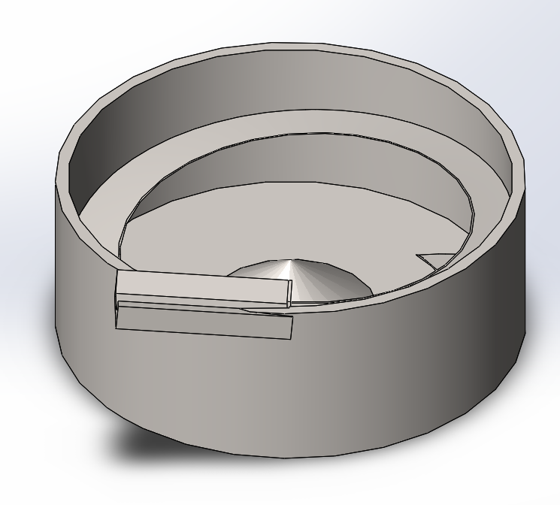**Key Mechanical Components:**

1. 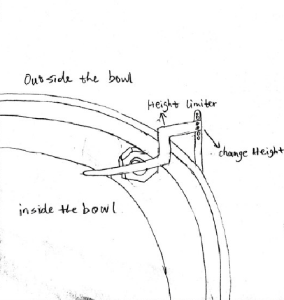Bowl feeder - serves as a hopper and transducer placed at the rear-end of the system

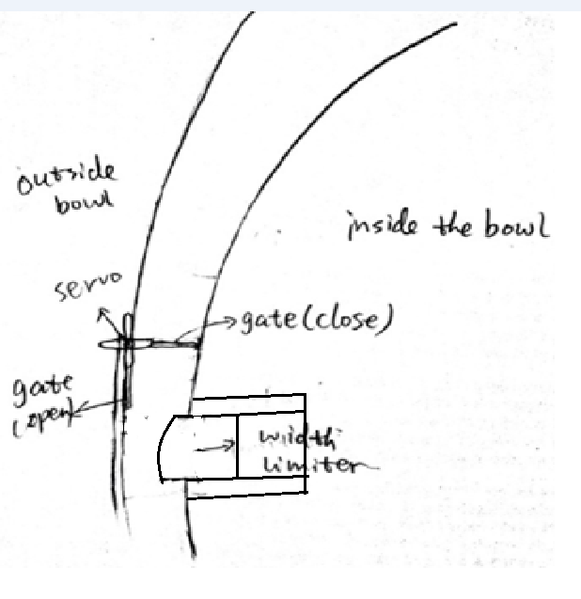

1. Inside the bowl - a control gate that is attached to an RC servo motor, and the spline that ascends to the top of the bowl and narrows along its path.

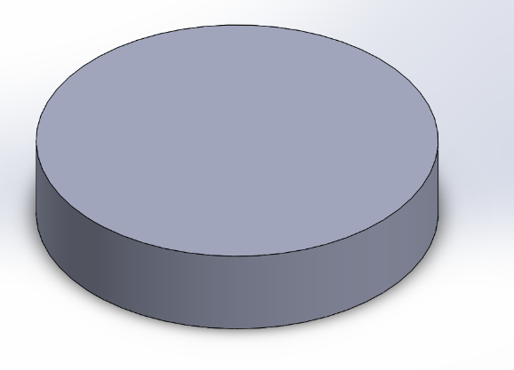

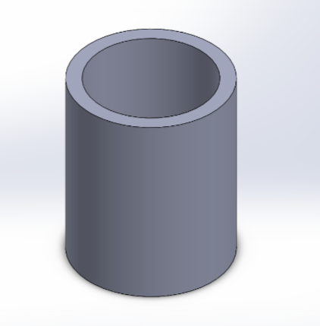3. Counter weight - The vibratory action of the bowl to begin and agitate the parts in the bottom of the bowl to start to move along the dispense path.

4. Parts counting chute - Attached to the tube are 6 pairs of diametrically opposing photo electronic sensors, evenly spaced to count parts to be dispensed and measure the velocity of those parts.

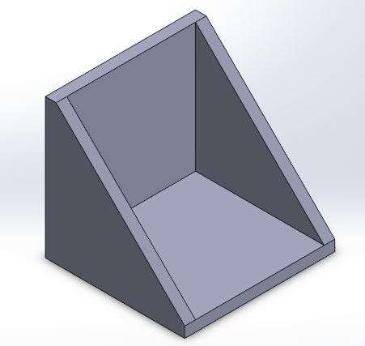

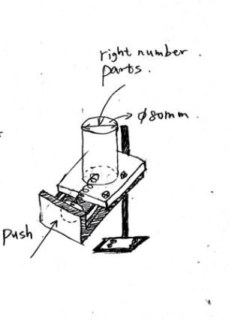

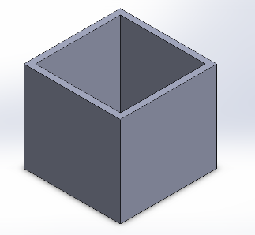

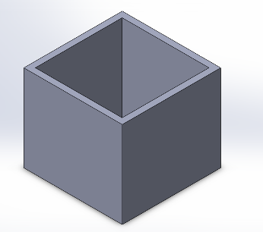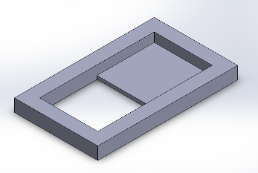

5. Count staging part, rejection bin, and presentation bin.

**Frame Assembly**

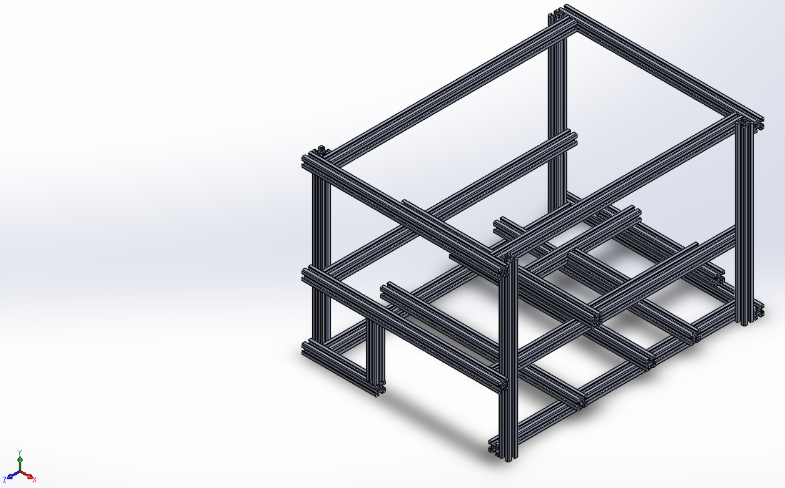

6. Frame uses 20mm X 20mm aluminum 80/20 beams. That can be cut to length and fixed to support the rest of the assembly inside.

**Final Assembly**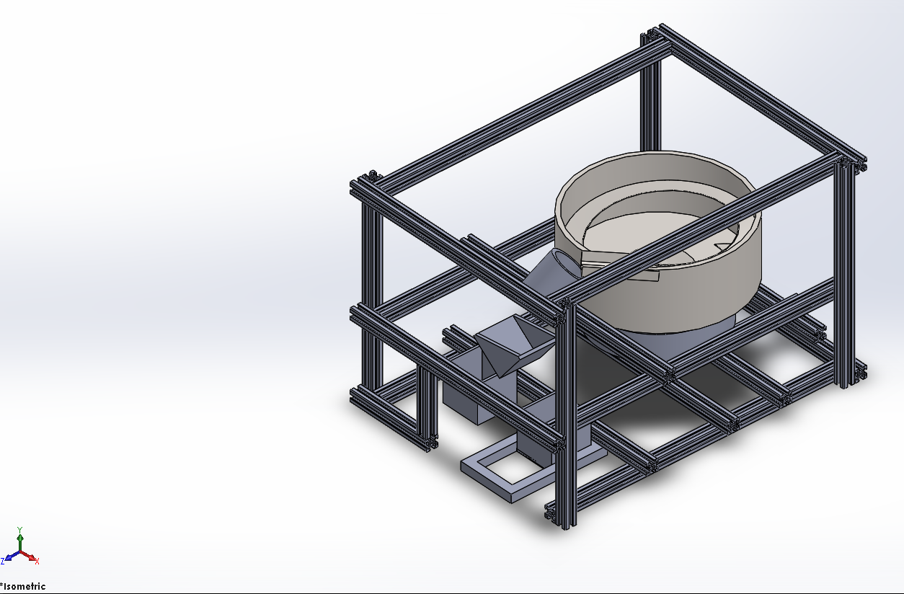

7. The final picture of all the components in their relative positions.

**Electrical and Electronic Components:**

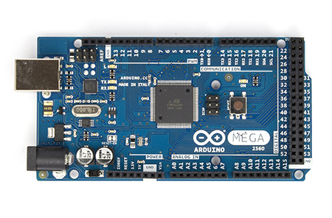

*Arduino Mega 2560 R3 Front*

8. Microcontoller selection: Arduino Mega 2560 R3

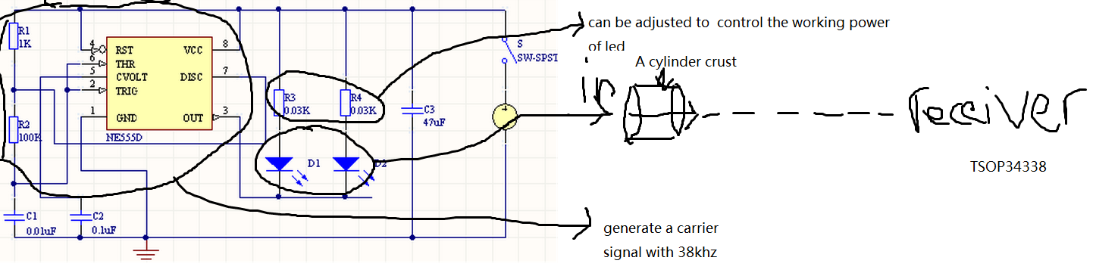

9. IR Sensor Design

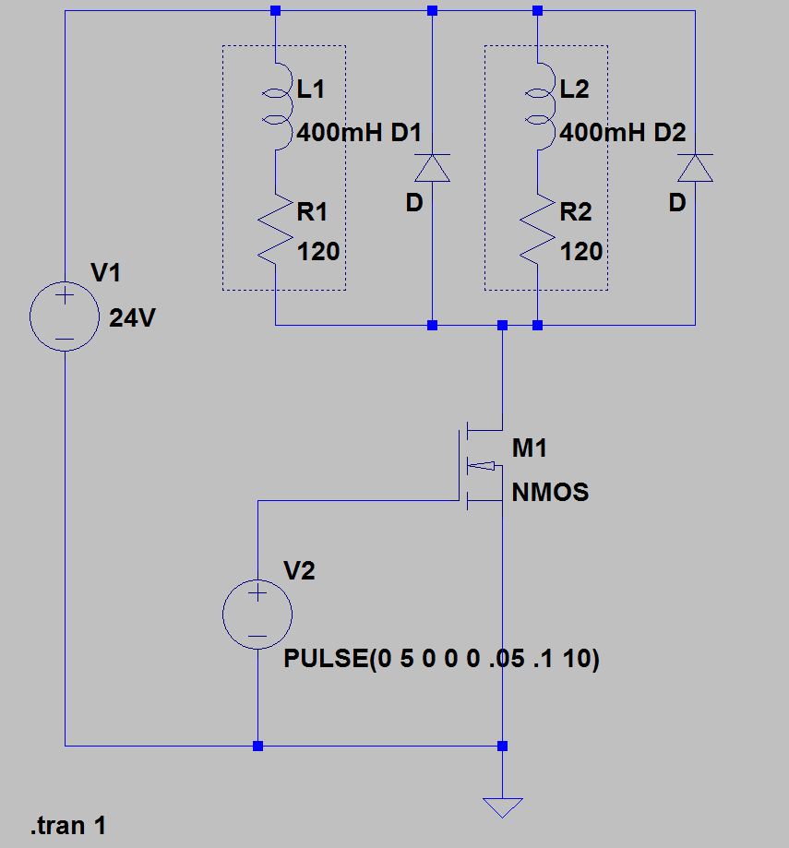

10. Solenoid driving circuit

**Expected Specifications and Features**

**1. Using IR led to make Ir emit and receive system**

**IR sensor working principal:**

IR light wave which is generated by IR led emit from IR emitter will catch by IR receive when emitter and receiver are setting in horizontal line. Therefore, if something goes through between emitter and receiver the item will block the light and the state of receiver will change, and then the counter will be count. We choose to use 38KHZ carrier wave to transport IR light to avoid the noise and some other disturb in the external environment.

Components: A 5mm IR led, IR receiver: TSOP34338, Timer IC: ne555d, Cylinder crust.

Resister, capacity, and wires

It is not necessary to add a lens in emit system, because IR led has already had similar structure.

**IR led : IR333-A**

Features

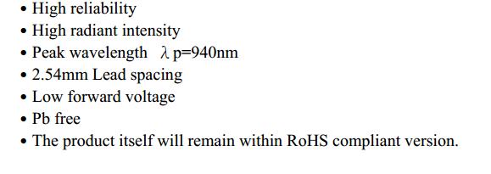

**IR receiver: TSOP34338**

Features:

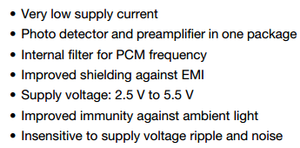

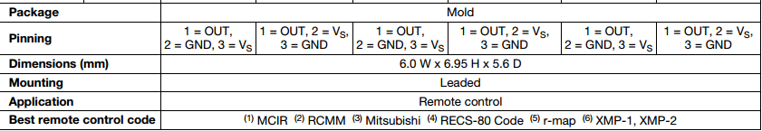

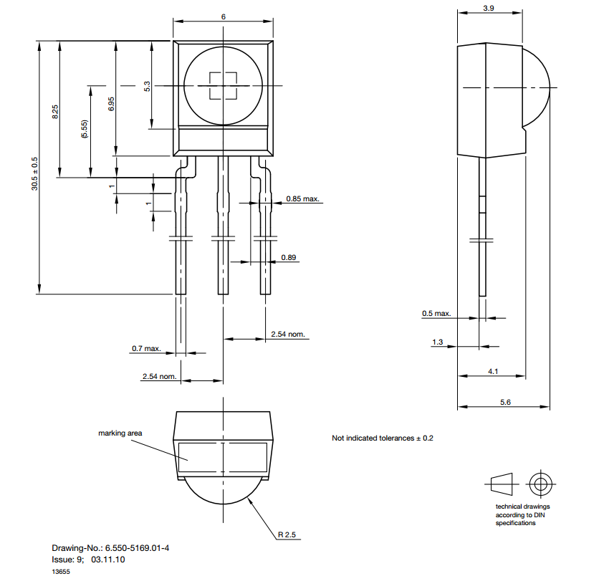

**3. proximity sensor depend on capacitive proximity sensor**

Capacitive proximity sensor working principal:

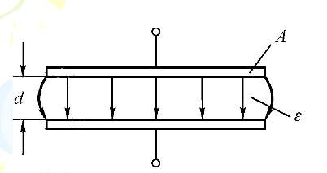

C=ε*s(available area)/d(distance between pole)

Application: proximity sensor

Work principal: by detecting the variation of capacity value when the item pass the capacitive proximity sensor to get the output signal. Then utilize this variational signal to change the system work state after amplify, rectify, and trigger.

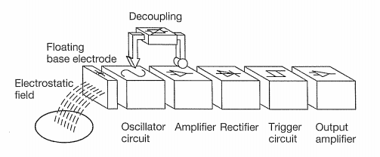

We don’t decide which model of capacitive proximity sensor we will use right now.

Microcontroller Specifications

|  |  |
| --- | --- |
| **PRODUCT INFORMATION** | |
| SKU | 194746 |
| Mfr Part# | 194159 |
| UPC | 618996977871 |
| **BOARDS/PROJECTS** | |
| Board Type | Arduino Mega2560 |
| Components | Mainboards |
| **MAINBOARDS** | |
| Board Color | Blue |
| Processor | ATmega2560 Microcontroller |
| Clock Rate | 16MHz |
| Operating Voltage | 5V |
| Input Voltage | 7V - 12V |
| Input Voltage (Limits) | 6V - 20V |
| Digital I/O Pins | 54 (of which 15 provide PWM output) |
| Analog Input Pins | 16 Pins |
| DC Current per I/O Pin | 40mA |
| DC Current for 3.3V Pin | 50mA |
| Flash Memory | 256KB |
| SDRAM | 8KB |
| EEPROM | 4KB |
| **WHAT IS IN THE BOX** | |
| What's in the Box | Arduino Mega 2560 |

**Design Considerations**

In order to come up with our design extensive research was done to see how parts are moved, counted, stored, contained and controlled in real world settings. After exploring some examples we started to consider our own design additions to make or add to designs that would in theory mimic the results of massive modern parts counting machines. We took away key pieces that each machine seemed to achieve to make it successful.

In order to choose a design, a chart was created for each feature that would have to take place in the machine. The events were ordered to follow the path of a single small part through each step in the machine’s processes. Where each step would need to physically be controlled and have the capability for an electrical system to view and provide feedback to the machines main electrical controls.

In order to hold the parts the machine needed a larger bin or space that could feed parts to the rest of the machine. The model of the bowl feeder design could hold large amounts of small parts and would be providing continuous feeding to the machine. Other hopper designs where considered however, it was deemed not necessary due to the expected part volume being too small to add another major part storage device.

The machine has to be able to physically move the small parts from the hopper to the rest of the machine, and it must do so efficiently and orderly. In order to move the parts, many examples that were observed used vibration methods, conveyor belts, rail systems and good old gravity. It was decided for this machine to attempt the vibration method due to most methods vibrated a bowl and ramp system which allowed for moving parts, storing parts and separating parts by orientation.

From the systems major flow of parts the amount of parts exiting the upstream portion of the machine was limiting the flow by means of spaces and gaps that would allow parts of one orientation to move through without falling back into the main population at the bottom of the bowl. These limitations allowed for a single oriented and controlled line of parts to be fed to the rest of the machine. For this project the machine will use a height limiter to prevent stacking of parts, an angled flow limiter to put parts into single file and a gate which will allow for the flow to be cut off from the rest of the machine when needed. It has been taken into consideration that each limiter will have manual adjusters in order to set up the limiters to handle different part sizes and shapes moving through the machine.

Once oriented and position to a single feed made slower accurate counting easier. It has been noted that some machines can count multiple small parts moving out to the machine at once, however the accuracy of the count and the speed of the machine have been deemed a risk to our application. It is recognized that this machine has been made to count slower and more times to ensure accuracy and control. The quantity that we need is finite and relatively small compared to machines counting 2000 parts a minute making counting this fast unnecessary. It is decided to use multiple sensors so that we can read multiple counts and compare counts to determine the correct count in the machine. The spacing and orientation of the sensors is a critical matter to be calculated, measured, and considered. To be on the safe side, we are counting and holding in a separate holder. If the count is correct the count will be dumped into an area that is waiting for user input. If the count is incorrect then the count will be put into a rejection bin where the parts can be manually put back into the main part population. By these methods we had considered a failsafe strategy for the machine.

The last method that each machine provided was to deliver the parts to their final holding area or destination. The project destination is a waiting hand; however the maximum number of parts to be presented is limited. Due to this we developed the idea based off of a soap dispenser, soda fountain, and ice water dispenser from a refrigerator, where the user puts a cup or a hand under the count holder and pushes a bumper that will allow for the parts to be dispensed vertically.

In order to contain the machine and support components we thought of building a cage where the machine components would be inside. Cage would act as a frame and would be built out of columns and beams to provide support to the components within the machine. It was noted that a machine in the senior design room was using a support system mainly out of 8020 beams and connectors that could be ordered in smaller sizes and be tailored to fit this machine. These pieces will hold up the vibrating bowl, the dispensing bins, the counter, the counting trough and the discard bin. The cage should be fitted with a Plexiglas to allow for observation but with a protective barrier between user and machine. It also serves to prevent foreign material from entering the machine.

As an added notion, it has been considered to add a counter weight with rubber isolators under the vibrating bowl in order to reduce the amount of excess vibration transfer to the rest of the machine. The isolators will be between the counter weight and supporting 8020 beams. Isolating the vibration in the machine will allow for a better count from the sensor and prevent the machine from shaking apart.

**Feasibility Analysis**

**Technical Feasibility, mathematical modeling of system mechanics**

Given an electromagnet-plunger solenoid system that can approximately model our armature-spring system:

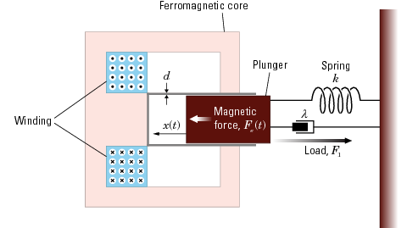

Equation of motion for the plunger:

Since,

Magnetic Force:

Change in inductance w.r.t. time:

Magnetic Force with solenoid constants:

The solenoid constants, α and β, can be solved by taking two force and stroke measurements and solving the expression.

The rotational motion of the bowl feeder can be written as the torque:

The angular acceleration can be written:

So rewriting yields:

To find the force needed to create this torque on the bowl, the torque can be written as the product of the force and the radius from the axis of rotation:

Solving for the force yields:

Substituting this expression into the overall equation of motion:

Simplifying:

Solving for :

Defining state space variables, and :

Substituting state space variables into equation of motion:

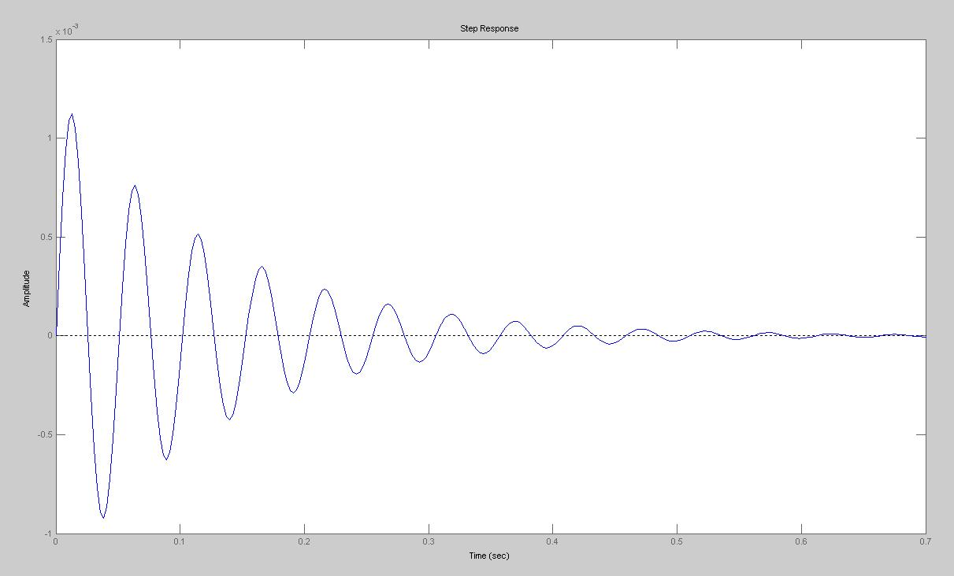

**System Step Response**

Judging from the system step response a PID controller will have to be implemented to create a more desirable and timely response.

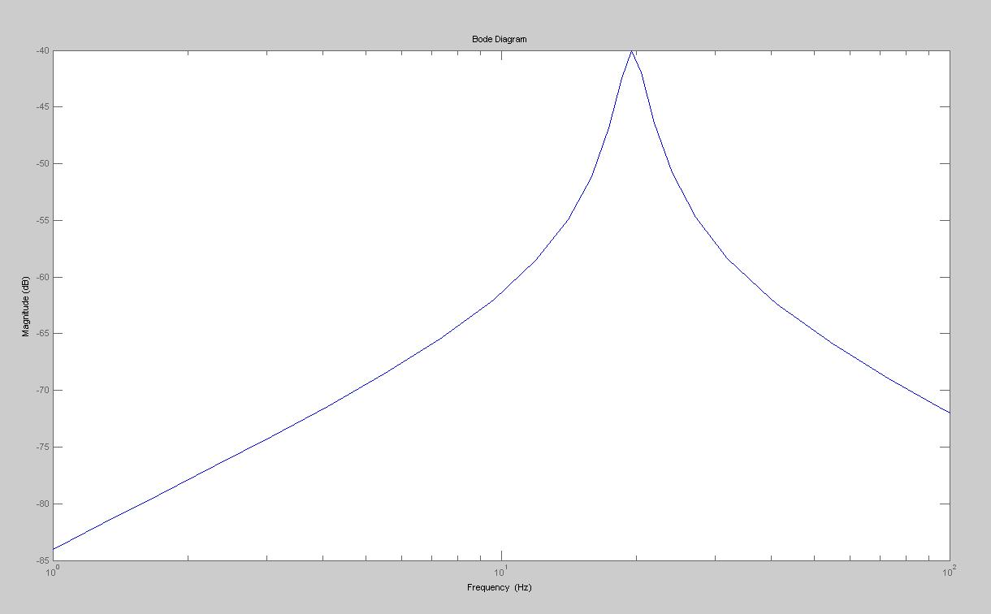

**Magnitude Frequency Response**

From analyzing the magnitude frequency response it can be seen that the system will need to be pulsed at 25~30Hz. In order to provide the necessary coupled moment and force to actuate the parts inside the feeder bowl.

**Potential Markets and Applications**

The system could efficiently and accurately count parts needed by an assembly worker and dispenses those parts into a worker’s awaiting hand. This kind of function can be applied on manufacturing as an advanced manufacturing facilities that can save a lot of time and labors. Before packaging, catching the exactly number of parts is important. Instead counting the parts by human being, a proper machine can do the work effectively and concisely. Additionally, the machine can count different types and different numbers of small parts by easily changing or adjusting the components. Although the system is now just suitable for no more than 50 parts, it can be developed to fit more parts to work better in the real industry. Further, this vibration system also can not only used to count one kind of parts, after some changes, it also can be used to classify different kind of parts, which will be very useful in the industry applications.

**Project Timeline**

**Appendix: System Requirements**